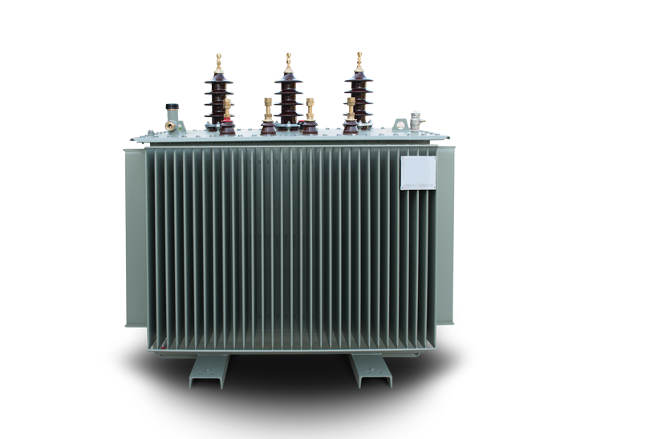

|  |  |  |  |  |  |  |  |  |
| --- | --- | --- | --- | --- | --- | --- | --- | --- |
| Tabela e te dhenave teknike ( Technical Data Sheet  Transformatoret e shperndarjes(Distribution Transformers) 20 /04 kV | | | | | | | | ) |
| Vlerat e ofruara(Offered)  Njesia(UNIT) 50 100 160 250 400  Pershkrimi(DESCRIPTION)  kVA kVA kVA kVA kVA | | | | | | | | 630  kVA |
| 1. Te dhena te pergjitheshme(GENERA L DATA) | | | | | | | |  |
|  | Prodhuesi(Manufacture )  Vendi prodhimit dheproves(Place of manufacture and test) Emertimi tipit(Type designation) |  | ELEKTROINVEST SH.P.K | | | | |  |
| TIRANE | | | | |  |
|  | | | | |  |
| 2 Vlerat(RATINGS) | | | | | | | |  |
|  | Standartiaplikuar(Applied standard) |  | IEC 60076 | | | | |  |
|  | Tensioni nominal(Rated voltage) | kV | 20/0.4 kV | | | | |  |
|  | Fuqia nominale(Rated power (Sn) | kVA | 50 | 100 | 160 | 250 | 400 | 630 |
|  | Vlera max. tensionit ne TM(Max. rated voltage, MV side (Um) | kV | 24 | 24 | 24 | 24 | 24 | 24 |
|  | Qendrushmeria ndaj tensionit impulsive(tensioni impulsive qe duron ) duron (Rated lightning impulse withstand voltage) (1.2/50 µs) | kV | 32 | 32 | 32 | 32 | 32 | 32 |
|  | Qendrushmeria ndaj tensionit me frekuancen e fuqise ne TM (Rated power frequency withstand voltage) (1 min.) | kV | 24 | 24 | 24 | 24 | 24 | 24 |
|  | Qendrushmeria ndaj tensionit me frekuancen e fuqise ne TU( LV rated power frequency withstand voltage) (1 min) | kV | 0,5 | 0,5 | 0,5 | 0,5 | 0,5 | 0,5 |
|  | Rryma ne primar(Primary rated current) | A | 1,44 | 2,89 | 4,62 | 7,22 | 11,56 | 18,2 |
|  | Rryma ne sekondar(Secondary rated current) | A | 72 | 144 | 230 | 360 | 576 | 907 |
|  | Grupi lidhjes(Vector group) |  | DYN-11 | DYN-11 | DYN-11 | DYN-11 | DYN-11 | DYN-11 |
|  | Frekuenca nominale (Rated frequency) | Hz | 50 | | | | |  |
|  | Shkallet e rregullimit ne TM(Tapping on MV) | % | ± 2 x 2.5 | | | | |  |
|  | Tensioni LSH ne 75 oC (Impedance voltage) (at 75 °C) uk | % | 4 | 4 | 4 | 4 | 4 | 4 |
|  | Sistemi tokezimit ne TM (MV neutral system) |  | I izoluar(isolated) | | | | |  |
|  | Tensioni nominal ne TU (Nominal low voltage) | V | 400/230 | | | | |  |
|  | Numri fazeve ne TM (MV number of phases) |  | 3 | | | | |  |
|  | Numri fazeve ne TU (LV number of phases) |  | 3 faze/4 percjellesa 3phase/4wire | | | | |  |
|  | Sistemi tokezimit ne TU (LV neutral system) |  | Direct ne toke(solidly ground) | | | | |  |
|  | Menyra e ftohjes (Type of cooling) |  | ONAN | | | | |  |
|  | Rritja maksimale e temperatures ne pjesen e siperme te vajit (Maximum temperature rise in top oil) | °C | 70 | 70 | 70 | 70 | 70 | 70 |
|  | Rritja maksimale e temperatures se peshtjelles ne pjesen me te nxehte (Maximum winding temperature rise (hottest layer) | °C | 75 | 75 | 75 | 75 | 75 | 75 |
|  | Max i vlerave te garantuara te humbjeve pa ngarkese (Max. guaranteed noload losses) | W | 135 | 220 | 310 | 430 | 615 | 865 |
|  | Max i vlerave te garantuara te humbjeve te ngarkeses ( Max. guaranteed load losses) | W | 1050 | 1760 | 480 | 2300 | 4600 | 6505 |
| 3 Dimensionet dhe peshat  (DIMENSIONS AND WEIGHTS) | | | | | | | |  |
|  | Pesha totale (Total Weight) | kg | 550 | 800 | 1100 | 1400 | 1900 | 2500 |
|  | Pesha e vajit (Oil Weight) | kg | 150 | 190 | 240 | 320 | 428 | 490 |
|  | Dimensionet e jashtme (Overall Dimensions) |  | | | | | |  |
|  | a) gjatesi(length) | mm | 1100 | 1150 | 1250 | 1320 | 1420 | 1620 |
|  | b) gjeresi (width) | mm | 550 | 650 | 650 | 800 | 800 | 930 |
|  | c)lartesi (height) | mm | 1150 | 1230 | 1320 | 1400 | 1520 | 1700 |
|  | | | | | | | | |