  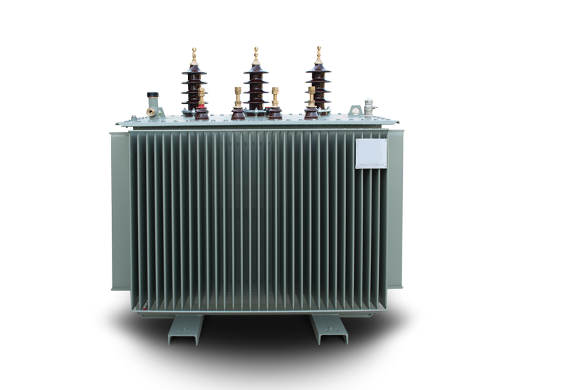Tabela e te dhenave teknike ( Technical Data Sheet  Transformatoret e shperndarjes(Distribution Transformers) 10 //04 kV |  |  |  |  |  |  |  | )
Vlerat e ofruara(Offered)  Njesia(UNIT) 50 100 160 250 400  Pershkrimi(DESCRIPTION)  kVA kVA kVA kVA kVA |  |  |  |  |  |  |  | 630  kVA
1. Te dhena te pergjitheshme(GENERA L DATA)
 | Prodhuesi(Manufacture )  Vendi prodhimit dheproves(Place of manufacture and test) Emertimi tipit(Type designation) |  | ELEKTROINVEST SH.P.K
 |  |  | TIRANE
2 Vlerat(RATINGS)
 | Standartiaplikuar(Applied standard) |  | IEC 60076
 | Tensioni nominal(Rated voltage) | kV | 10/0.4 kV
 | Fuqia nominale(Rated power (Sn) | kVA | 50 | 100 | 160 | 250 | 400 | 630
 | Vlera max. tensionit ne TM(Max. rated voltage, MV side (Um) | kV
 | Qendrushmeria ndaj tensionit impulsive(tensioni impulsive qe duron ) duron (Rated lightning impulse withstand voltage) (1.2/50 µs) | kV | 12 | 12 |  | 12 | 12
 | Qendrushmeria ndaj tensionit me frekuancen e fuqise ne TM (Rated power frequency withstand voltage) (1 min.) | kV | 16 | 16 |  | 16 | 16
 | Qendrushmeria ndaj tensionit me frekuancen e fuqise ne TU( LV rated power frequency withstand voltage) (1 min) | kV | 1 | 1 |  | 1 | 1
 | Rryma ne primar(Primary rated current) | A | 2,88 | 5,77 |  | 14,43 | 23
 | Rryma ne sekondar(Secondary rated current) | A | 72,1 | 144,3 |  | 360,8 | 577,3
 | Grupi lidhjes(Vector group) |  | DNY-11 | DNY-11 |  | DNY-11 | DNY-11
 | Frekuenca nominale (Rated frequency) | Hz | 50
 | Shkallet e rregullimit ne TM(Tapping on MV) | % | ± 2 x 2.5
 | Tensioni LSH ne 75 _{o}C (Impedance voltage) (at 75 °C) uk | %
 | Sistemi tokezimit ne TM (MV neutral system) |  | I izoluar(isolated)
 | Tensioni nominal ne TU (Nominal low voltage) | V | 400/230
 | Numri fazeve ne TM (MV number of phases) |  | 3
 | Numri fazeve ne TU (LV number of phases) |  | 3 faze/4 percjellesa3phase/4wire
 | Sistemi tokezimit ne TU (LV neutral system) |  | Direct ne toke(solidly ground)
 | Menyra e ftohjes (Type of cooling) |  | ONAN
 | Rritja maksimale e temperatures ne pjesen e siperme te vajit (Maximum temperature rise in top oil) | °C | 70 | 70 |  | 70 | 70
 | Rritja maksimale e temperatures se peshtjelles ne pjesen me te nxehte (Maximum winding temperature rise (hottest layer) | °C | 75 | 75 |  | 75 | 75
 | Max i vlerave te garantuara te humbjeve pa ngarkese (Max. guaranteed noload losses) | W | 135 | 220 | 310 | 430 | 615 | 865
 | Max i vlerave te garantuara te humbjeve te ngarkeses ( Max. guaranteed load losses) | W | 1050 | 1760 | 480 | 2300 | 4600 | 6505
3 Dimensionet dhe peshat
(DIMENSIONS AND WEIGHTS)
 | Pesha totale (Total Weight) | kg | 430 | 520 |  | 880 | 1250
 | Pesha e vajit (Oil Weight) | kg | 100 | 130 |  | 190 | 250
 | Dimensionet e jashtme (Overall Dimensions)
 | a) gjatesi(length) | mm | 1000 | 1150 |  | 1300 | 1400
 | b) gjeresi (width) | mm | 570 | 650 |  | 800 | 850
 | c)lartesi (height) | mm | 1100 | 1150 |  | 1300 | 1400

